Controller

* It handles the changing of screens.
* Collect input and transferring it to the model for final processing.
* Transfer final information from model to view.
* Calling Methods from view and after checking proper implementation, transfer to model.

Data base

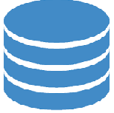

View

* Implement methods that are called from

the controller.

* First testing and after checking proper implementation, transferring to the controller.

MODEL

Interacts with the Data base and saves temporary reservation details throw all the process.